**1.INTRODUCTION**

**1.1 Overview**

Agriculture is the most important sector of Indian Economy.The issue of damage to crops by wild creatures has turned into a noteworthy social issue in current occasions.

Existing method include building wire fences and electric fences which are not so effective.

Thus,Artificial Intelligence has brought a new solution to crop protection in an effective way.

**1.2 Purpose**

The purpose is to protect agricultural lands and crops from animals.Animals intrusion happens mainly in areas near to the national parks and wildlife sanctuaries.

It is not possible for farmers to monitor their lands and crops 24x7.

And another thing is, it gives reliable security and safety of crops.It give the guarantees of well being creatures while warding them off.

It hepls farmers by alerting them when animal tries to intrude into their lands and crops.

**2.LITERATURE SURVEY**

**2.1 Existing Problem**

Electric fences inflict shock on animals and also there is a possibility of fire hazard if plants or shrubs grow too close to fence.

If the fence is not maintained properly, it creates electromagnetic interferences which affect telephoe and radio transmissions.

Electric fencing is lethal to both animal life and human life though it is the most commonly used farm protection technique. Thorn fencing which is likewise a pervasive strategy followed has a similar impact as the previous one.

**2.2 Proposed Solution**

This project provides a smart solution to resolve this problem.In this project,image is captured when an animal try to intrude using Conventional Neural Network(CNN) and deep learning technique.

This helps in alerting the ultrasonic electronic repellent sensor to send waves according to the animal without harming them physically. The smart farm protectection system gives reliable security and safety to crops.It likewise diminishes the exertion made by man in securing the field.

**3.THEORATICAL ANALYSIS**

**3.1 Block Diagram**

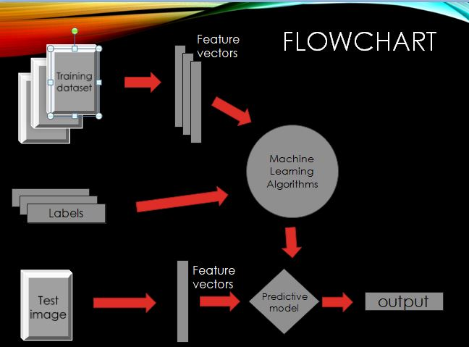

**3.2 Hardware/Software Designing**

Hardware

-Ultrasonic Electronic repellent

Software

-Tensorflow

-Keras

-OpenCV python3

**4.Experimental Investigation**

Through this experiment,we came across libraries like tensorflow,keras and opencv and CNN a deep learning technique which is

used to recognise images captured on field in this experiment.

These libraries are used to train models with ease.Keras library is more user friendly than the tensorflow library.

**5.FlowChart**

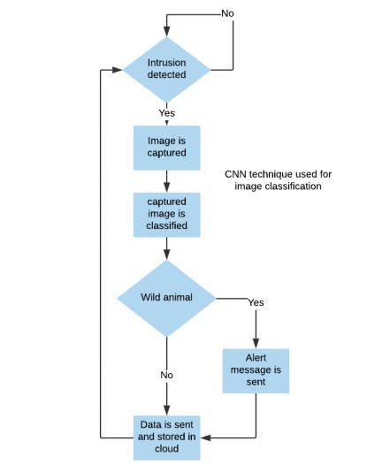

**6.Result**

Once the intrusion of animals detected, captured image will be detected and alert the farmer.So that he can protect crops from animals.

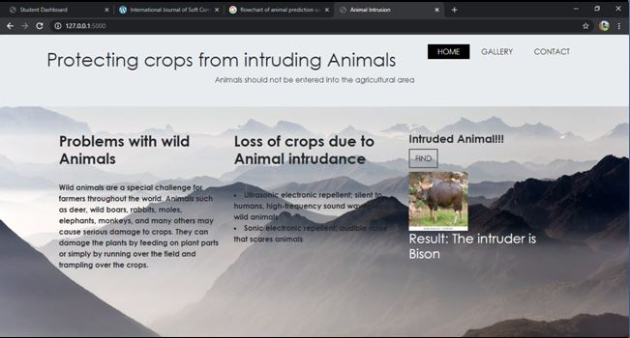

**7. Advantages and Disadvantages**

Advantages

-No surveillance of human.

-Can observe the intrusion of wild creatures remotely.

Disadvantages

-will need electricity 24x7.

-high cost of implementation.

**8. Applications**

**-**For the safety of crops,this system prevents animals from destroying the crops.

-It seems to be good security features for farmers.

**9. Conclusion**

Nowadays the issue of form vandalization by wild creatures has turned into a major social issue..

It requires dire consideration as no viable solution exists till date for the issue.

This project is exceptionally viable in driving off the animals from the fields and keeps them away.

Implementation of the crop protection system.can be done in a large scale also with multiple sensor at different nodes.

This will save and alert the people nearby. As future work, if latency needs to be very low,edge/fog computing can be used.

**10.Future Scope**

In this model, cameras are fixed around the fields.when animal is captured by the camera our cnn framework classifies the animal and ultrosonic electronic repellant emits ultrosonic waves and diverts the path of animal.

This keeps the agricultural feild free of intruding animal.

**11.Bibilography**

1.Dataset from <https://www.rug.nl/research/portal/datasets/wildanim-dataset(0927dcb1-d542-4681-9599-f26d998c169f).html>

**Source Code**

from keras.models import Sequential

from keras.layers import Dense

from keras.layers import Convolution2D

from keras.layers import MaxPooling2D

from keras.layers import Flatten

from keras.preprocessing.image import ImageDataGenerator

train_datagen=ImageDataGenerator(rescale=1./255,shear_range=0.2,zoom_range=0.2,horizontal_flip=True)

test_datagen=ImageDataGenerator(rescale=1./255)

x_train=train_datagen.flow_from_directory(r"C:\Users\Rajesh\Desktop\Dataset\TrainSet",target_size=(64,64),batch_size=32)

x_test=train_datagen.flow_from_directory(r"C:\Users\Rajesh\Desktop\Dataset\TestSet",target_size=(64,64),batch_size=32)

x_train.class_indices

model=Sequential()

model.add(Convolution2D(32,(3,3),input_shape=(64,64,3),activation="relu"))

model.add(MaxPooling2D(pool_size=(2,2)))

model.add(Flatten())

model.add(Dense(units=128,init="uniform",activation="relu"))

model.add(Dense(units=5,init="uniform",activation="softmax"))

model.compile(loss="categorical_crossentropy",optimizer="adam",metrics=["accuracy"])

model.fit_generator(x_train,steps_per_epoch=56,validation_data=x_test,validation_steps=16,epochs=20)

from keras.models import load_model

from keras.preprocessing import image

img = image.load_img(r"G:\Pics\Ooty, Mudumalai, Topslip, Dodebetta - 2008\daddy cell\DSC00377.jpg",target_size = (64,64))

import numpy as np

x = image.img_to_array(img)

x = np.expand_dims(x,axis = 0)

x.shape

ypred=model.predict_classes(x)

index=['Bison','Deer','Elephant','WildBoar','Zebra']

print(index[ypred[0]])

model.save("cropprotection.h5")